# Foreword

Note: Copying code from Word document may not work due to Jupyter not recognising the ‘ ‘ symbol from Word.

# Importing

* Import pandas as pd
* Import numpy as np
* Import matplotlib.pyplot as plt

Importing gets us the necessary python packages. The “as” is the function to use, i.e., pd.read_csv.

# Data Frames

* Df = pd.read_csv(r”FilePath”)

This tells python where the data for the data frame is.

* Df

Typing DF displays the data

* Df.set_index(“Date”)

Sets the data column as the index column, replacing the other indexed column (in this example, the 0 – 6).

# Plot()

## Default/Line

Ctrl + Tab when in df.plot() shows us the type of plots available and other valuable information

* Df.plot() this command by itself shows a basic graph
* Df.plot(kind = ‘line’) produces a line graph
* Line is default

Subplots

* Df.plot(kind = ‘line’, subplots = True)

This divides the plot into subplots

* Title = ‘Ice Cream Ratings’

Adds a title to the visual

Editing the axis

Xlabel = ‘Daily Ratings’

Ylabel = ‘Scores’

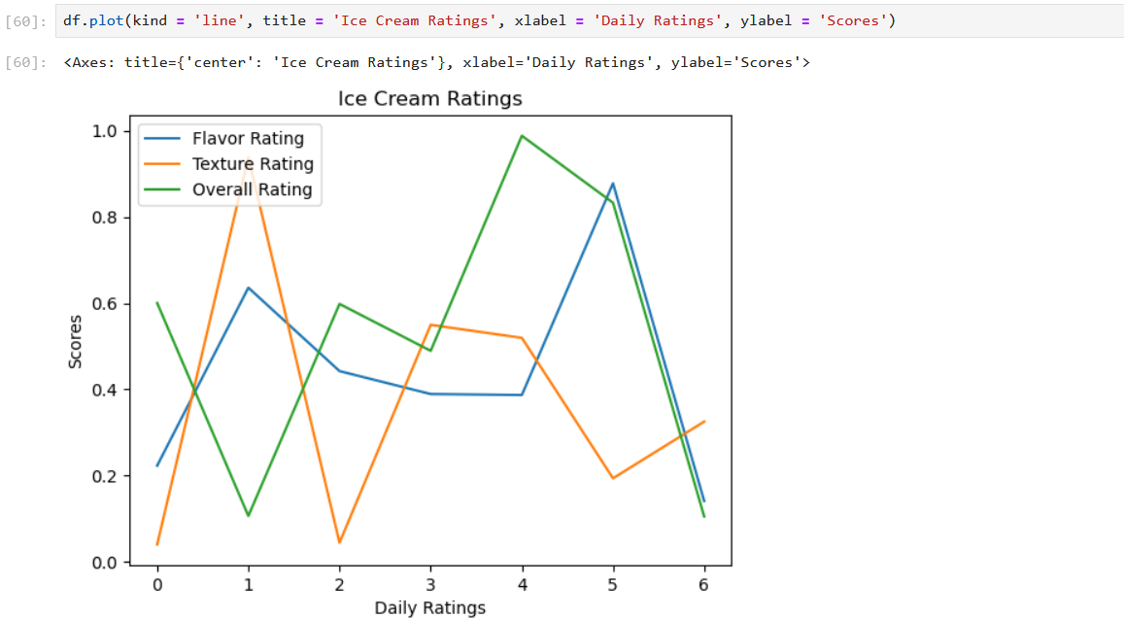

## Bar

Kind = ‘bar’

Unique to bar plot; stacked bar plot

Stacked = True

* df.plot(kind = 'bar', title = 'Ice Cream Ratings', xlabel = 'Daily Ratings', ylabel = 'Scores', stacked = True)

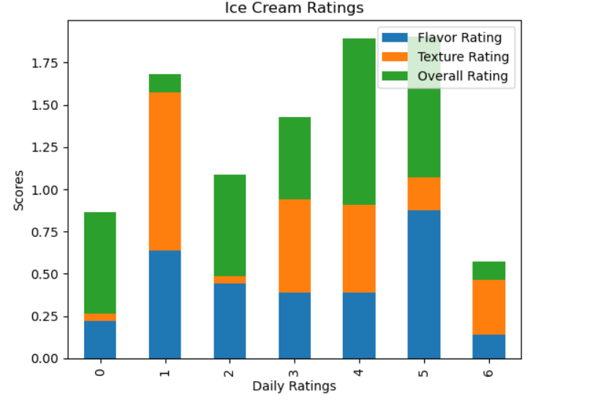

Defining a column;

* df['Flavor Rating'].plot(kind = 'bar', stacked = True)

Only displays a chart of the Flavor Rating column.

* Df.plot.barh(stacked = True)

Changes the orientation of the bar chart to horizontal (h).

## Scatterplots

* df.plot.scatter(x = 'Texture Rating', y = 'Overall Rating')

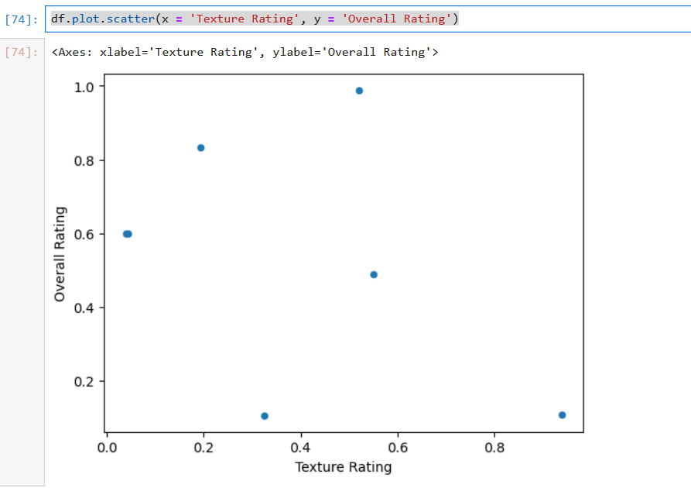

Resizing dot size s = 100

* df.plot.scatter(x = ‘Texture Rating’, y = ‘Overall Rating’, s = 100)

Changing colour of dot = c = ‘Yellow’

* df.plot.scatter( x = ‘Texture Rating’, y = ‘Overall Rating’, s = 100, c = ‘Yellow’)

## Histogram

Df.plot.hist()

* good for showing distribution of variables – does not make much sense with current data type.

Df.plot.hist(bins = 100)

## Boxplot

Df.boxplot()

Shows min and max, mean values

## Area plot

Df.plot.area(figsize = (10,5))

## Pie Charts

Df.plot.pie(y = ‘Flavor Rating’,figsize = (10,6))

## Styling charts

Print(plt.style.available) shows the types of styles available

